Assembling Maintenance and Troubleshooting Tools
Physical Topology

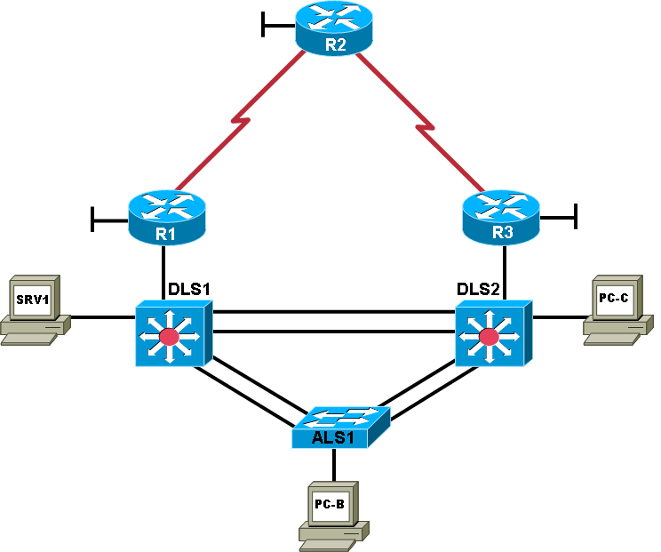

Objectives
- Use available tools to document key device configuration parameters, such as the interfaces in use, IP addressing, routing protocols, VLANs, logging mechanisms, and security measures.
- Document the physical topology to support future troubleshooting tasks.
- Document the logical topology to support future troubleshooting tasks.

Background
You have been employed as a network engineering consultant by a company that has made a recent acquisition. The documentation for the acquired company’s network is incomplete and outdated, so you need to inventory their network architecture both logically and physically, per company documentation standards. This will help you learn about the design and implementation of their network and ensure that you have access to up-to-date and accurate network documentation to reference during future troubleshooting procedures.
In this lab, you survey the baseline TSHOOT network. No problems are introduced in this lab. This network will evolve over time as changes and enhancements are made. You will analyze and document the current topology and device configuration parameters to develop familiarity with the baseline configurations and network connections. You will review and fill out the provided documentation as you evaluate the network. You will assess and assemble tools that can be used for future maintenance and troubleshooting tasks.
Note: This lab uses Cisco 1841 routers with Cisco IOS Release 12.4(24)T and the Advanced IP Services image c1841-advipservicesk9-mz.124-24.T.bin. The switches are Cisco WS-C2960-24TT-L with the Cisco IOS image c2960-lanbasek9-mz.150-2.SE4.bin and Catalyst 3650-24PS with the Cisco IOS image (CAT3K_CAA-UNIVERSALK9-M), Version 16.3.2. Depending on the router or switch model and Cisco IOS Software version, the commands available and output produced might vary from what is shown in this lab.

Required Resources
- 3 routers (Cisco 1841 with Cisco IOS Release 12.4(24)T1 Advanced IP Service or comparable)
- 1 switch (Cisco 2960 with the Cisco IOS Release 12.2(46)SE C2960-LANBASEK9-M image or comparable)
- 2 switches (Cisco 3650 with the Cisco IOS Release (CAT3K_CAA-UNIVERSALK9-M), Version 16.3.2
- SRV1 (with static IP address): RADIUS, TFTP, and syslog servers, plus an SSH client
- PC-B (DHCP and SSH client)
- PC-C (DHCP and SSH client)
- Serial and Ethernet cables, as shown in the topology
- Rollover cables to configure the routers and switches via the console

Task 1: Load the Baseline Device Configuration Files

Step 1: Configure the PCs.
- Configure SRV1 with the static IP address 10.1.50.1/24 and the default gateway 10.1.50.254.
- Configure PC-B and PC-C as DHCP clients.

Step 2: Test basic network connectivity between devices.
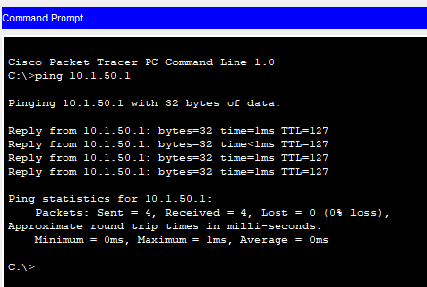
- Ping from PC-B to SRV1 at 10.1.50.1. Were the pings successful? _____YES________

- Ping from ALS1 to R2 at loopback 10.1.202.1. Were the pings successful? ____YES____________
Note: If the pings are not successful, verify the configuration.
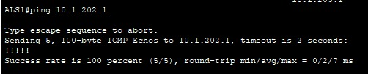

Task 2: Analyze and Document the Physical Topology
Note: At this time, only examine and document the physical connections. Documenting the logical topology, such as subnets, IP addresses, and routing protocols, is addressed in Task 4 of this lab.

Step 1: Review the physical topology diagram on page 1 of the lab.

Step 2: Use Cisco Discovery Protocol and show commands to verify the Layer 1 and Layer 2 connections of the lab topology.
- Use the show cdp command to discover the interfaces associated with the physical connections. Fill in the correct device and interface designators in the following Device Links table and label them on the physical topology diagram on the first page of the lab.
Documenting the text output of the commands you have used (copy & paste):
ALS1#show cdp neighbors
Capability Codes: R - Router, T - Trans Bridge, B - Source Route Bridge S - Switch, H - Host, I - IGMP, r - Repeater, P - Phone
Device ID Local Intrfce Holdtme Capability Platform Port ID
DLS1 Por 1 121 3650 Gig 1/0/1
DLS1 Por 1 121 3650 Gig 1/0/2
DLS1 Por 1 121 3650 Por 1
DLS2 Por 2 164 3650 Gig 1/0/1
DLS2 Por 2 164 3650 Gig 1/0/2
DLS2 Por 2 164 3650 Por 2

DLS1#show cdp neighbors
Capability Codes: R - Router, T - Trans Bridge, B - Source Route Bridge S - Switch, H - Host, I - IGMP, r - Repeater, P - Phone
Device ID Local Intrfce Holdtme Capability Platform Port ID DLS2 Por 10 134 3650 Gig 1/0/3
DLS2 Por 10 134 3650 Gig 1/0/4
DLS2 Por 10 134 3650 Por 10
ALS1 Por 1 140 S 2960 Fas 0/1
ALS1 Por 1 140 S 2960 Fas 0/2
ALS1 Por 1 140 S 2960 Por 1
R1 Gig 1/0/5 131 R C1841 Fas 0/1

DLS2#show cdp neighbors
Capability Codes: R - Router, T - Trans Bridge, B - Source Route Bridge S - Switch, H - Host, I - IGMP, r - Repeater, P - Phone
Device ID Local Intrfce Holdtme Capability Platform Port ID ALS1 Por 2 153 S 2960 Fas 0/3
ALS1 Por 2 153 S 2960 Fas 0/4
ALS1 Por 2 153 S 2960 Por 2
DLS1 Por 10 164 3650 Gig 1/0/3
DLS1 Por 10 164 3650 Gig 1/0/4
DLS1 Por 10 164 3650 Por 10
R3 Gig 1/0/5 138 R C1841 Fas 0/1 DLS2#

R3#show cdp neighbors
Capability Codes: R - Router, T - Trans Bridge, B - Source Route Bridge S - Switch, H - Host, I - IGMP, r - Repeater, P - Phone
Device ID Local Intrfce Holdtme Capability Platform Port ID DLS2 Fas 0/1 178 3650 Gig 1/0/5

R1#show cdp neighbors
Capability Codes: R - Router, T - Trans Bridge, B - Source Route Bridge S - Switch, H - Host, I - IGMP, r - Repeater, P - Phone
Device ID Local Intrfce Holdtme Capability Platform Port ID DLS1 Fas 0/1 129 3650 Gig 1/0/5

- Review the configurations of the devices for using Layer 1 and Layer 2 features, such as trunks and EtherChannels. Fill in the information in the Device Links table and add it to the diagram. If a link is accounted for from one device to another, it is not necessary to repeat the entry from the other device. The first entry for ALS1, interface Fa0/1 is filled in as an example.
Which other commands could you use to identify Layer 1 and Layer 2 characteristics?

Documenting the text output of the commands you have used (copy & paste):
ALS1#show interfaces trunk
Port Mode Encapsulation Status Native vlan Po1 on 802.1q trunking 900
Po2 on 802.1q trunking 900

Port Vlans allowed on trunk Po1 10,20,30,100
Po2 10,20,30,100
Port Vlans allowed and active in management domain Po1 10,20,30,100
Po2 10,20,30,100

Port Vlans in spanning tree forwarding state and not pruned Po1 10,30,100
Po2 20

ALS1#show etherchannel summary Flags: D - down P - in port-channel I - stand-alone s - suspended
H - Hot-standby (LACP only) R - Layer3 S - Layer2
U - in use f - failed to allocate aggregator u - unsuitable for bundling
w - waiting to be aggregated d - default port
Number of channel-groups in use: 2 Number of aggregators: 2

Group Port-channel Protocol Ports
+ + +
1 Po1(SU) - Fa0/1(P) Fa0/2(P)
2 Po2(SU) - Fa0/3(P) Fa0/4(P)

ALS1#show interfaces status
Port Name Status Vlan Duplex Speed TypePo1 Channel to DLS1 connected trunk auto auto Po2 Channel to DLS2 connected trunk auto auto
Fa0/1 Channel to DLS1 connected trunk auto auto 10/100BaseTX Fa0/2 Channel to DLS1 connected trunk auto auto 10/100BaseTX Fa0/3 Channel to DLS2 connected trunk auto auto 10/100BaseTX Fa0/4 Channel to DLS2 connected trunk auto auto 10/100BaseTX Fa0/5 Unused disabled 999 auto auto 10/100BaseTX
Fa0/6 Unused disabled 999 auto auto 10/100BaseTX Fa0/7 Unused disabled 999 auto auto 10/100BaseTX Fa0/8 Unused disabled 999 auto auto 10/100BaseTX Fa0/9 Unused disabled 999 auto auto 10/100BaseTX Fa0/10 Unused disabled 999 auto auto 10/100BaseTX Fa0/11 Unused disabled 999 auto auto 10/100BaseTX Fa0/12 Unused disabled 999 auto auto 10/100BaseTX Fa0/13 Unused disabled 999 auto auto 10/100BaseTX Fa0/14 Unused disabled 999 auto auto 10/100BaseTX Fa0/15 Unused disabled 999 auto auto 10/100BaseTX Fa0/16 Unused disabled 999 auto auto 10/100BaseTX Fa0/17 Unused disabled 999 auto auto 10/100BaseTX Fa0/18 To PC-B connected 10 auto auto 10/100BaseTX Fa0/19 Unused disabled 999 auto auto 10/100BaseTX Fa0/20 Unused disabled 999 auto auto 10/100BaseTX Fa0/21 Unused disabled 999 auto auto 10/100BaseTX Fa0/22 Unused disabled 999 auto auto 10/100BaseTX Fa0/23 Unused disabled 999 auto auto 10/100BaseTX Fa0/24 Unused disabled 999 auto auto 10/100BaseTX Gig0/1 Unused disabled 999 auto auto 10/100BaseTX Gig0/2 Unused disabled 999 auto auto 10/100BaseTX

Device Links Table

From Device | Interface | To Device | Interface | Layer 1 and 2 Features and Protocols Used
ALS1 | Fa0/1 | DLS1 | G1/0/1 | EtherChannel Po1, 802.1Q
ALS1 | Fa0/2 | DLS1 | G1/0/2 | EtheChannel Po1,802.1Q
ALS1 | Fa0/3 | DLS2 | G1/0/1 | EtheChannel Po1,802.1Q
ALS1 | Fa0/4 | DLS2 | G1/0/2 | EtheChannel Po1,802.1Q
ALS1 | Fa0/18 | PC-B | Fa0 | Spanning tree portfast, 100Base-T
DLS1 | G1/0/3 | DLS2 | G1/0/3 | EthernetChannel Po10, 802.1Q
DLS1 | G1/0/4 | DLS2 | G1/0/4 | EthernetChannel Po10, 802.1Q
DLS1 | G1/0/5 | R1 | Fa0/1 | EIGRP, 100Base-Tx
DLS1 | G1/0/6 | SRV1 | Fa0 | Spanning tree portfast, 100Base-T
DLS2 | G1/0/5 | R2 | Fa0/1 | EIGRP, 100Base-Tx
DLS2 | G1/0/18 | PC-C | Fa0 | Spanning tree portfast, 100Base-T
R1 | Se0/0/0 | R2 | Se0/0/0 | EIGRP WAN LINK, PPP
R3 | Se0/0/1 | R2 | Se0/0/1 | EIGRP WAN LINK, PPP

- Verify that all physical links shown in the diagram are operational. Which commands did you use?
Listing the commands you have used:
Show interfaces trunk
show etherchannel summary show interfaces status
show interface (for routers)

Step 3: Map the VLANs used in the lab to the devices in the diagram.
Fill in the VLAN Definition table and label the physical topology diagram with the VLANs used for this topology. Identify all host devices that are members of each VLAN. The first entry for VLAN 10 is filled in as an example.
VLAN Definition Table
VLAN # | Name | Description | VLAN Members
10 | OFFICE | Office VLAN | ALS1, DLS1, DLS2, PC-B
20 | VOICE | Voice VLAN | ALS1, DLS1, DLS2, PC-B
30 | GUEST | Guest VLAN | ALS1, DLS1, DLS2, PC-C
100 | MGMT | Management VLAN | ALS1, DLS1, DLS2
900 | NATIVE | Native VLAN | ALS1, DLS1, DLS2
50 | Server | Server VLAN | SRV1, DLS1, DLS2

Step 4: Analyze spanning tree for the Layer 2 switched domain.
- Analyze the spanning tree characteristics of the Layer 2 switched portion of the network. Which type of spanning-tree mode is implemented?
Your answer:
Command Given: show running-config

enabled protocol rapid-pvst [Rapid Per VLAN Spanning Tree protocol is enabled]

- Which switch is the root switch for each VLAN, and what are the configured spanning-tree priorities?
Your answer:
DLS1 is the root switch for vlan 10,30,100 – priority=24576 Vlan20,50 – priority = 28672
DLS2 is the root switch for vlan 20,50 – priority = 24576 Vlan 10,30,100 – priority = 28672
ALS1 is the root switch for VLAN 900 – priority = 33668

- What is the resulting spanning-tree topology for VLANs that have client devices connected?
Your answer:
ALS1#show spanning-tree VLAN0010
Spanning tree enabled protocol rstp Root ID Priority 24586
Address 00D0.BAE7.D73E
Cost 9
Port 27(Port-channel1)

Hello Time 2 sec Max Age 20 sec Forward Delay 15 sec

Bridge ID Priority 32778 (priority 32768 sys-id-ext 10) Address 000A.4173.87C5
Hello Time 2 sec Max Age 20 sec Forward Delay 15 sec Aging Time 20

Interface Role Sts Cost Prio.Nbr Type

Fa0/18 Desg FWD 19 128.18 P2p
Po1 Root FWD 9 128.27 Shr
Po2 Altn BLK 9 128.28 Shr

VLAN0020
Spanning tree enabled protocol rstp Root ID Priority 24596
Address 0060.2F88.9487
Cost 9
Port 28(Port-channel2)
Hello Time 2 sec Max Age 20 sec Forward Delay 15 sec

Bridge ID Priority 32788 (priority 32768 sys-id-ext 20) Address 000A.4173.87C5
Hello Time 2 sec Max Age 20 sec Forward Delay 15 sec Aging Time 20

Interface Role Sts Cost Prio.Nbr Type

Fa0/18 Desg FWD 19 128.18 P2p
Po1 Altn BLK 9 128.27 Shr
Po2 Root FWD 9 128.28 Shr
VLAN0030
Spanning tree enabled protocol rstp Root ID Priority 24606
Address 00D0.BAE7.D73E
Cost 9
Port 27(Port-channel1)
Hello Time 2 sec Max Age 20 sec Forward Delay 15 sec

Bridge ID Priority 32798 (priority 32768 sys-id-ext 30) Address 000A.4173.87C5
Hello Time 2 sec Max Age 20 sec Forward Delay 15 sec Aging Time 20

Interface Role Sts Cost Prio.Nbr Type
Po1 Root FWD 9 128.27 Shr
Po2 Altn BLK 9 128.28 Shr

VLAN0100
Spanning tree enabled protocol rstp Root ID Priority 24676
Address 00D0.BAE7.D73E
Cost 9
Port 27(Port-channel1)
Hello Time 2 sec Max Age 20 sec Forward Delay 15 sec

Bridge ID Priority 32868 (priority 32768 sys-id-ext 100) Address 000A.4173.87C5
Hello Time 2 sec Max Age 20 sec Forward Delay 15 sec Aging Time 20
Interface Role Sts Cost Prio.Nbr Type Po1 Root FWD 9 128.27 Shr
Po2 Altn BLK 9 128.28 Shr
VLAN0900
Spanning tree enabled protocol rstp Root ID Priority 33668
Address 000A.4173.87C5
This bridge is the root
Hello Time 2 sec Max Age 20 sec Forward Delay 15 sec

Bridge ID Priority 33668 (priority 32768 sys-id-ext 900) Address 000A.4173.87C5
Hello Time 2 sec Max Age 20 sec Forward Delay 15 sec Aging Time 20
Interface Role Sts Cost Prio.Nbr Type Po1 Desg FWD 9 128.27 Shr
Po2 Desg FWD 9 128.28 Shr

- Which commands did you use to analyze the spanning-tree characteristics?
Your answer: Show spanning-tree

Step 5: Diagram the spanning tree for VLAN 10.
- Label the STP role, port status, and direction for each port channel used in the physical topology diagram below. [using Insert -> Text Box or other Shapes tools to add labels on each device about its STP role and port status]
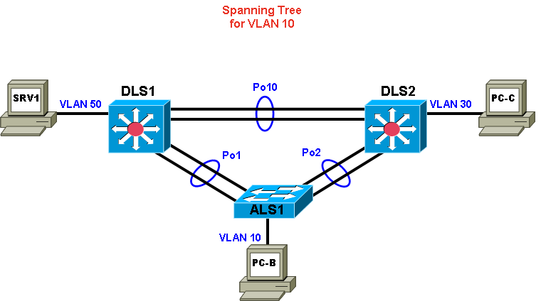

Task 3: Analyze and Document the Logical Lab Topology

Step 1: Review the logical lab diagram and the subnets.
Review the IP subnets in the Subnet table for the VLANs and WAN links that are used in the lab network. Router interface designations from the physical topology diagram are provided.
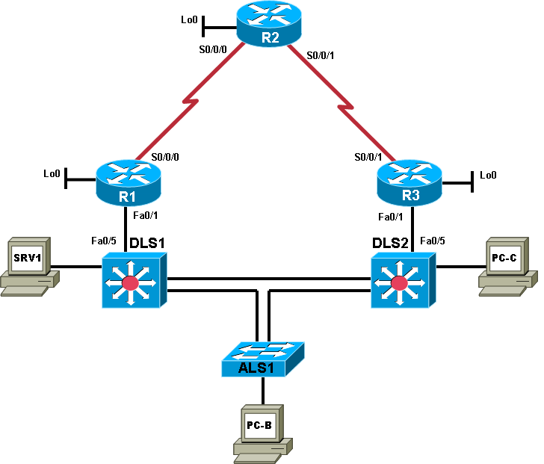

Subnet Table
Description | Subnet | Prefix | Devices
VLANs
Office VLAN 10 | 10.1.10.0 | /24 | PC-B
Voice VLAN 20 | 10.1.20.0 | /24 | N/A
Guest VLAN 30 | 10.1.30.0 | /24 | PC-C
Servers VLAN 50 | 10.1.50.0 | /24 | SRV1
Management VLAN | 10.1.100.0 | /24 | ALS1, DLS1, DLS2
WAN Links
DLS1 – R1 | 10.1.2.0 | /30 | DLS1 and R1 FE link
DLS2 – R3 | 10.1.2.12 | /30 | DLS2 and R3 FE link
R1 – R2 | 10.1.1.0 | /30 | R1 and R2 serial link
R2 – R3 | 10.1.1.4 | /30 | R2 and R3 serial link

Step 2: Map the subnet scheme to the logical diagram.
In the previous step, the subnets were documented in the Subnet table. Now document the host portion of the addresses. To document the host part, research the routing tables and interface IP addresses of all the devices. Document the management VLAN and interface addresses in the IP Address table and on the logical topology diagram. Use only the number of the last octet for IP addresses in the diagram. The device names and interfaces are listed to help identify the IP addresses. The entry for ALS1 VLAN 100 is shown as an example. If an interface is not in use, indicate this in the Additional Information column. Account for all interfaces on the routers.
IP Address Table
Device Name Abbreviation | Interface | Network Address and Prefix | Additional Information
ALS1 | Vlan 100 | 10.1.100.1/24 | SVI
DLS1 | Vlan 100 | 10.1.100.252/24 | Mgmt. SVI
DLS1 | Fa0/5 | 10.1.2.1/24 | To R1
DLS2 | Vlan 100 | 10.1.100.253/24 | Mgmt. SVI
DLS2 | Fa0/5 | 10.1.2.13/30 | To R3
R1 | Fa0/0 | - | -
R1 | Fa0/1 | 10.1.2.2/30 | To DLS1
R1 | S0/0/0 | 10.1.1.1/30 | To R2
R1 | S0/0/1 | - | -
R1 | Loopback 0 | 10.1.201.1/32 | Loopback
R2 | Fa0/0 | - | -
R2 | Fa0/1 | - | -
R2 | S0/0/0 | 10.1.1.2/30 | To R1
R2 | S0/0/1 | 10.1.1.6/30 | To R3
R2 | Loopback 0 | 10.1.202.1/32 | Loopback
R3 | Fa0/0 | - | -
R3 | Fa0/1 | 10.1.2.14/30 | To DLS2
R3 | S0/0/0 | 10.1.1.5/30 | To R2
R3 | S0/0/1 | - | -
R3 | Loopback 0 | 10.1.203.1/32 | Loopback
SRV1 | NIC | 10.1.50.1/8 | Static IP
PC-B | NIC | 10.1.10.1/8 | DHCP
PC-C | NIC | 10.1.30.1/8 | DHCP

Step 3: Analyze and document control plane logical configuration features.
Analyze the configurations of the devices for control plane features such as routing protocols, First Hop Redundancy Protocols (FHRPs), dynamic host configuration protocol (DHCP), and network address translation (NAT). Review, document, and discuss the following aspects of the logical network configuration.
- Is dynamic or static routing being used?
Your Answer: Dynamic Routing ( i.e DHCP)

- If dynamic, which routing protocol?
Your Answer: EIGRP

- Are FHRPs in use, such as the Hot Standby Router Protocol (HSRP), Virtual Router Redundancy Protocol (VRRP), or Gateway Load Balancing Protocol (GLBP)? If yes, which one?
Your Answer: Yes, Hot Standby Router Protocol (HSRP)

- What is the active router for all relevant VLANs?
Your Answer: DLS1 for VLANs 10,30 and 100 (DLS2 standby)
DLS2 for VLANs 20 and 50 (DLS1 standby)

- From the PC-B command prompt, issue the tracert command to router R2 loopback 0 at 10.1.202.1. What path did the packets take?
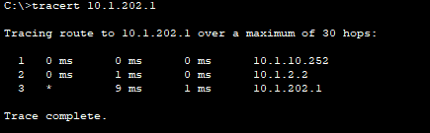
Your Answer (documenting the text output of the command):
- Are any access lists used to filter traffic on the network? If yes, describe their function.
Your Answer: NO

- Is DHCP in use? If yes, which DHCP server is used and for which VLANs present in the logical topology diagram?
Your Answer: Yes, DLS1 is used as DHCP server
DHCP lease ips to VLANs 10,20 and 30.

Task 4: Identify Troubleshooting and Maintenance Tools

Step 1: Analyze device configurations for troubleshooting and maintenance features.
Analyze the configurations of the devices for services that support troubleshooting and maintenance, such as syslog, Simple Network Management Protocol (SNMP), and other network management features.

Step 2: Document the troubleshooting and maintenance features.
- Document the troubleshooting and maintenance applications or tools in use with the network devices in the Troubleshooting and Maintenance Tools table. An entry for system logging is provided as an example.
Troubleshooting and Maintenance Tools Table
Configured Feature | Devices | Target Server | Target Tool or Application
System message logging | All | SRV1 | Syslog server
SNMP | All | SRV1 | Syslog Server
NTP | All | R2 | NTP Server
Netflow | R1, R3 | SRV1 | Netflow Monitor

Task 5: Identify the Security Measures Implemented

Step 1: Analyze device configurations for security-related features.
Analyze the configurations of your assigned devices for configuration options that help support a more secure network implementation, such as password security, login authentication, secure remote management, switch trunk and access port security, and VLANs. Record your entries in the Security Features table. An entry for password security is provided as an example.
Security Features Table
Security Feature Configured | Implementation Method or Commands
Password security | Enable secret, password encryption
VLAN Security | Unused port assigned to VLAN 999 and Native VLAN changed to 900
Password Protected Login | AAA based authentication method for login and privileged mode
Secure Remote Access | SSH is enabled
Switch port security | Switch port mode – trunk, specific VLAN are allowed on trunk, nonnegotiate.

Debrief Notes
Use this space to make notes of the key learning points that you picked up during the debrief discussions with your instructor. This can include alternate solutions, methods, and processes, procedure and communication improvements, as well as key commands and tools.
Note: This is your primary opportunity to document a baseline of the lab network before starting the troubleshooting exercises. During the debrief session, ask your instructor for clarification of any aspects of the network design and configurations that are unclear to you.

********************************************

